Title
Model Explainability and Bias Analysis for Churn Prediction

🟦 1. Objective
To analyze model interpretability and fairness using SHAP and evaluate bias across sensitive attributes.

🟦 2. Feature Importance
Feature importance was computed using Random Forest.
Top features influencing churn include:
- (write top features from your graph)

🟦 3. SHAP Analysis
SHAP was used to explain model predictions:
- Global explanation using summary plot
- Local explanation for individual prediction

🟦 4. Bias Analysis
Bias was checked across:
- Gender
- Senior Citizen

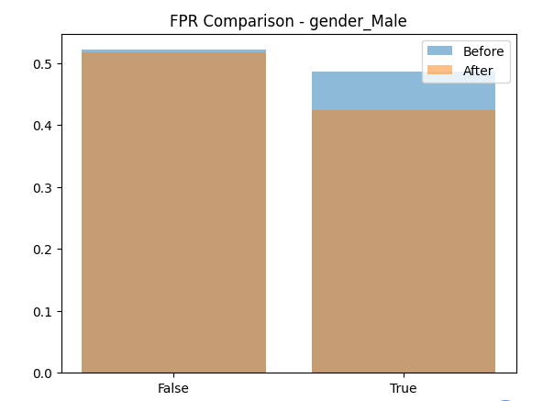

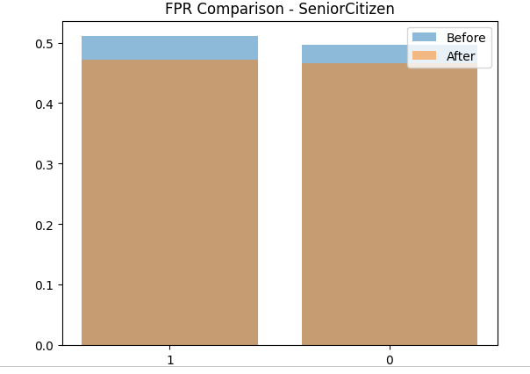

5. Mitigation Strategies
- Balance dataset (oversampling/undersampling)
- Remove sensitive attributes
- Use fairness-aware algorithms
- Regular bias monitoring

6. Conclusion
The model shows interpretability using SHAP. Some bias may exist across sensitive groups, and mitigation techniques can improve fairness.

7.Screenshots
